To load multiple file gen2 to blob by using dataset and pipeline parameter and trigger, security mechanism and authentication types

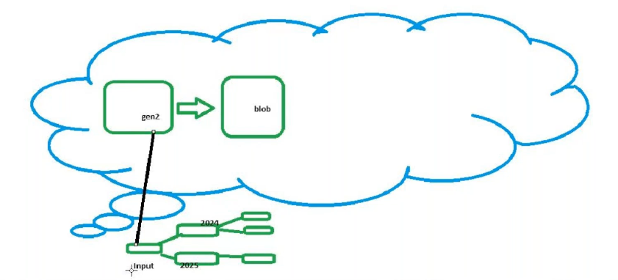
Inside gen2 create a container in side create 2 folder in side folders upload the files

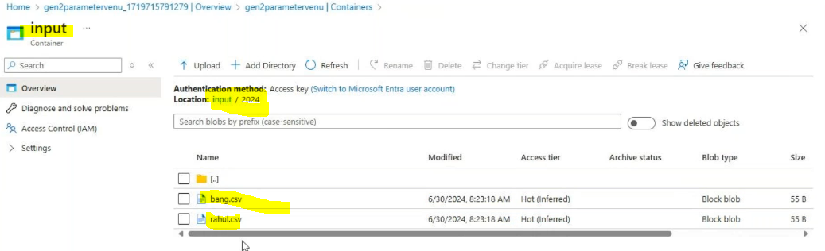
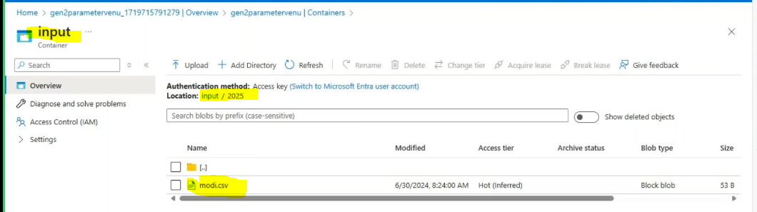
In blob create output container
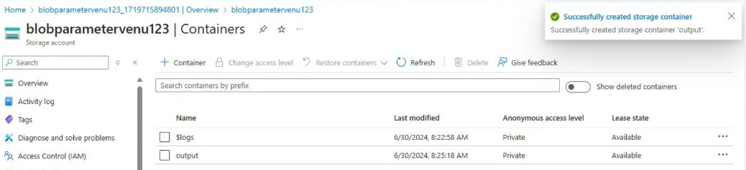

Create integration run time(default)
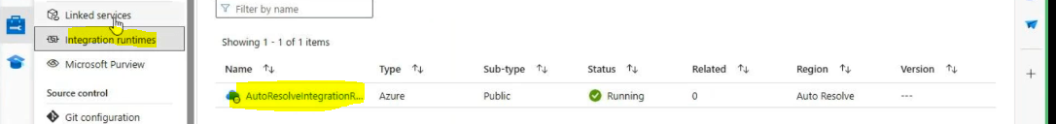

Create linked services
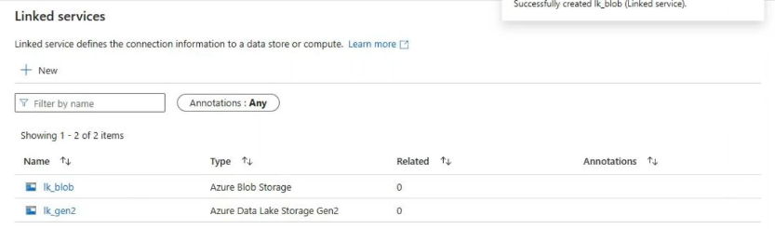
Source data set directory and files should be empty(cause need to upload the 2 folders)
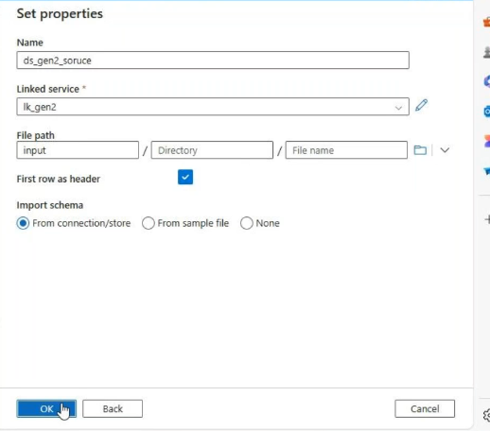
Sink side dataset
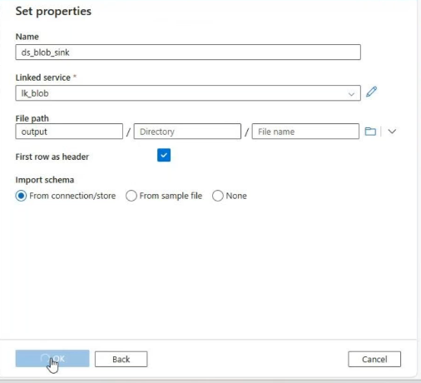
Create a pipeline and create copy data activity

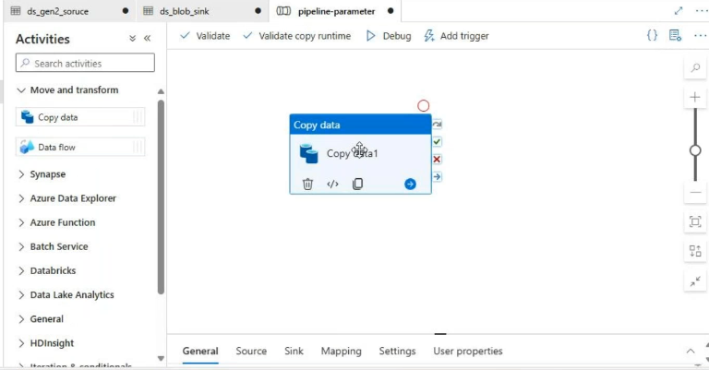

Source_side(wild card file path cause need to copy the all folders * means all folders)
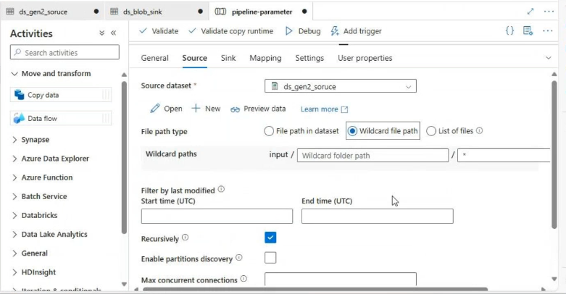
Sink_side:
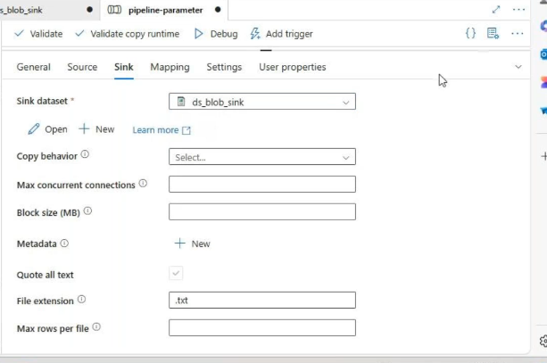

Validate & debug
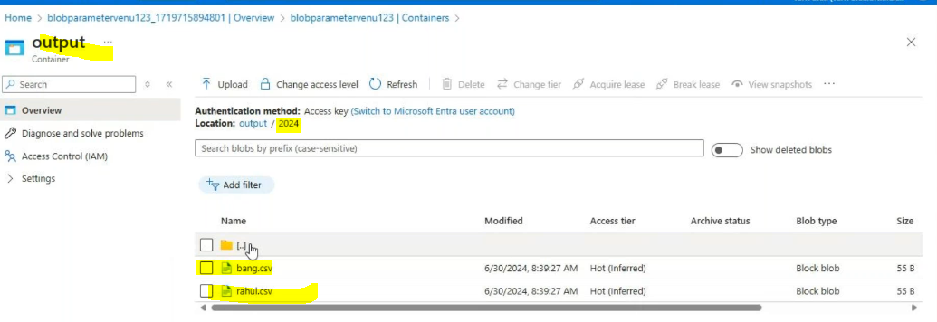
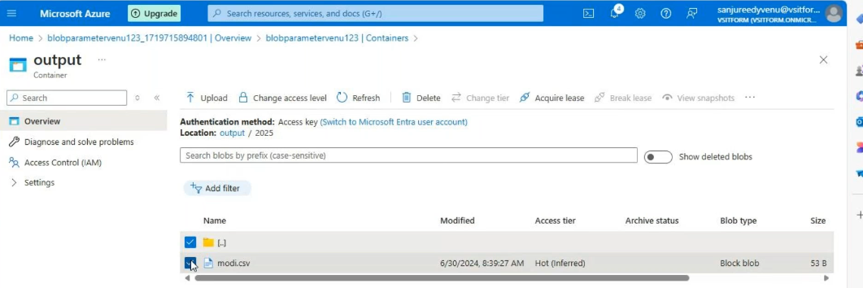

Then delete the 2024 and 2025 folders
Parameterized concepts
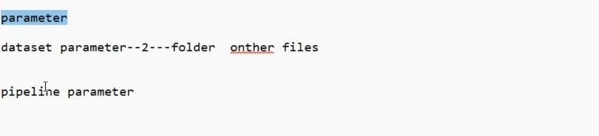

Source_side_datasets:open the source side dataset

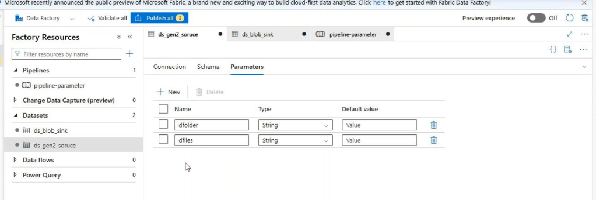
Connection :
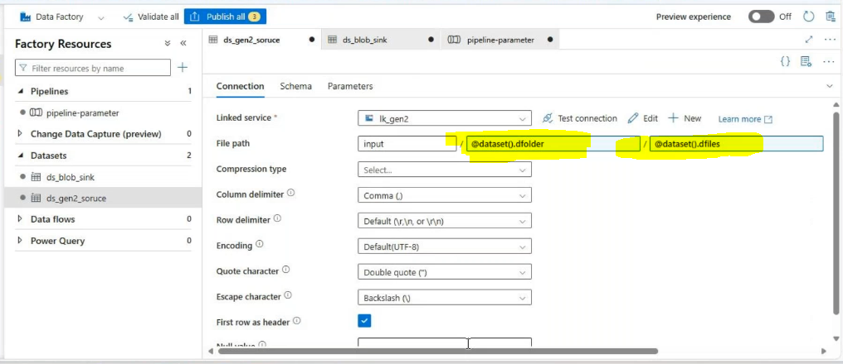

Sink_side_datasets:open the sink side dataset
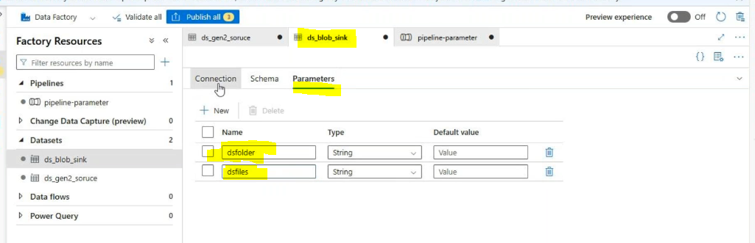
Connections:
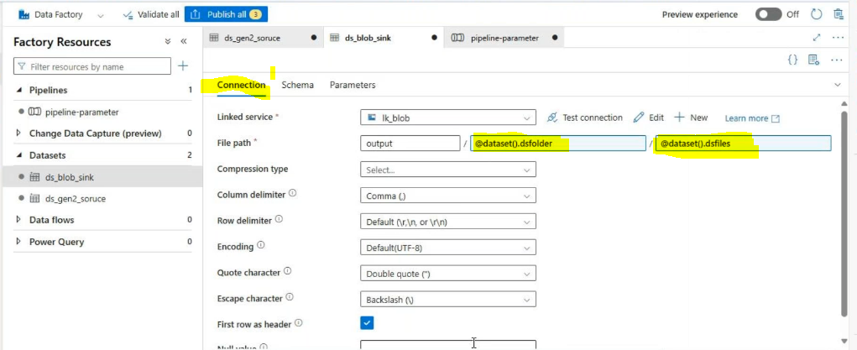
Under pipeline: disable the copy data activity(pfolder&pfiles are like source side parameters)
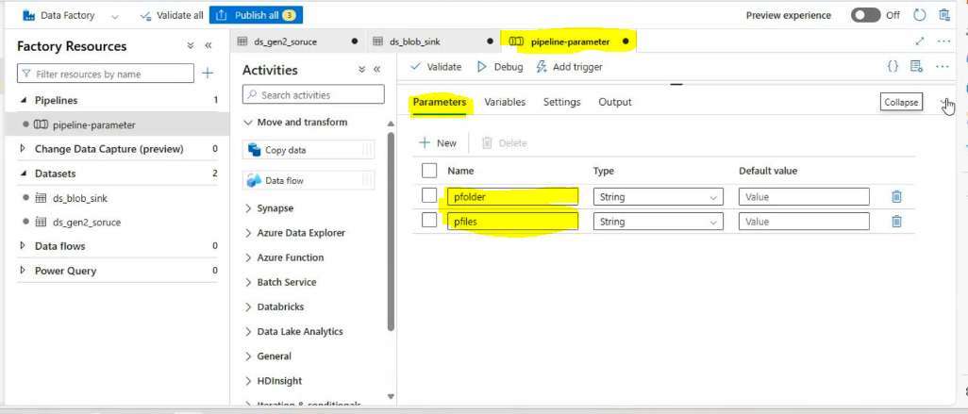
Under pipeline: disable the copy data activity(psfolder&psfiles are like sinkside parameters)

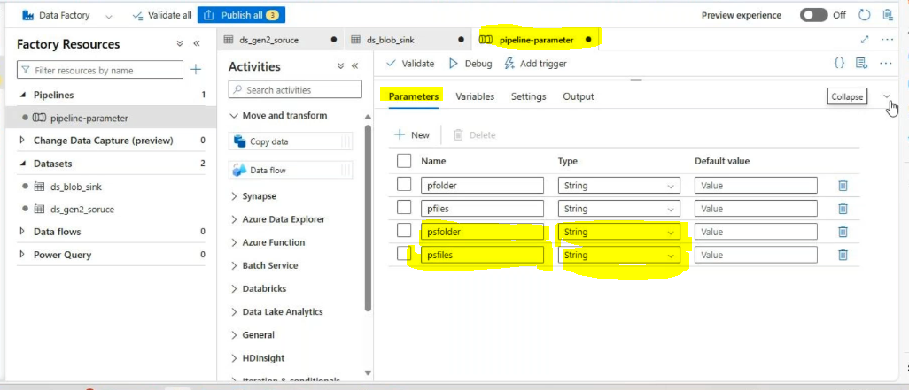
Pipeline level :enable copy data activity(source side)
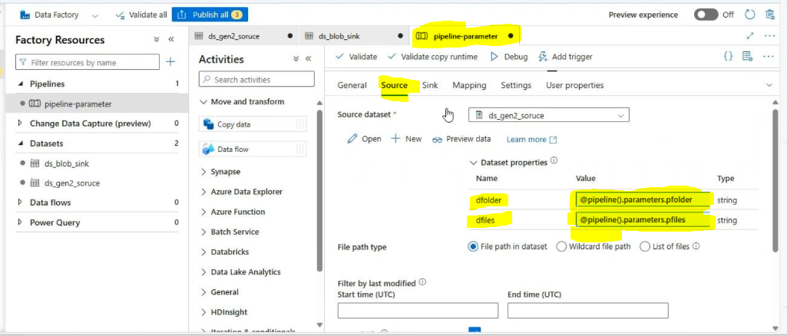
Pipeline level : enable copy data activity(sink side)
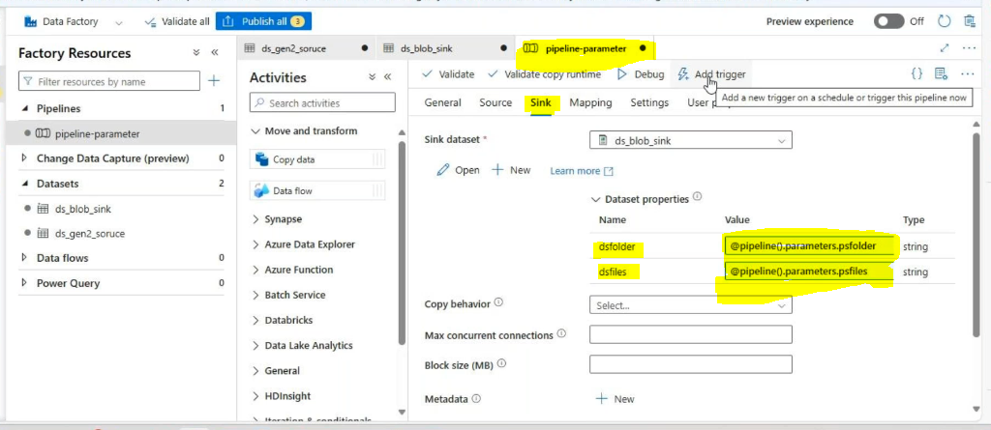
Then go to triggers:
New&edit
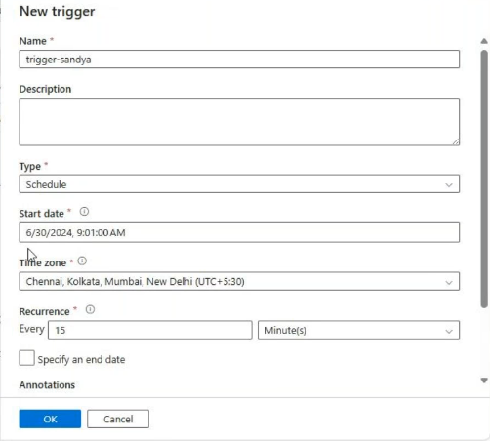
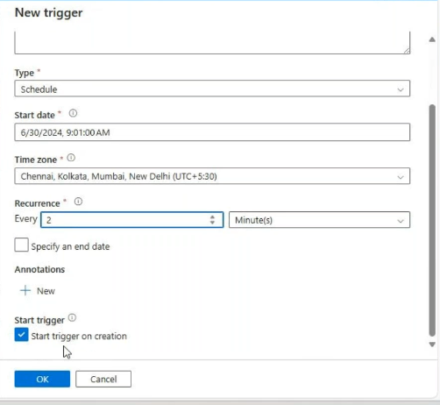

After Validate
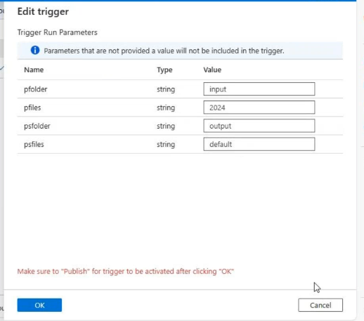
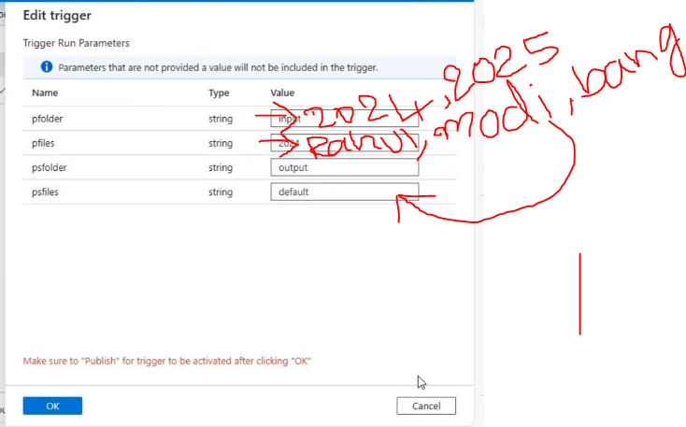

debug

